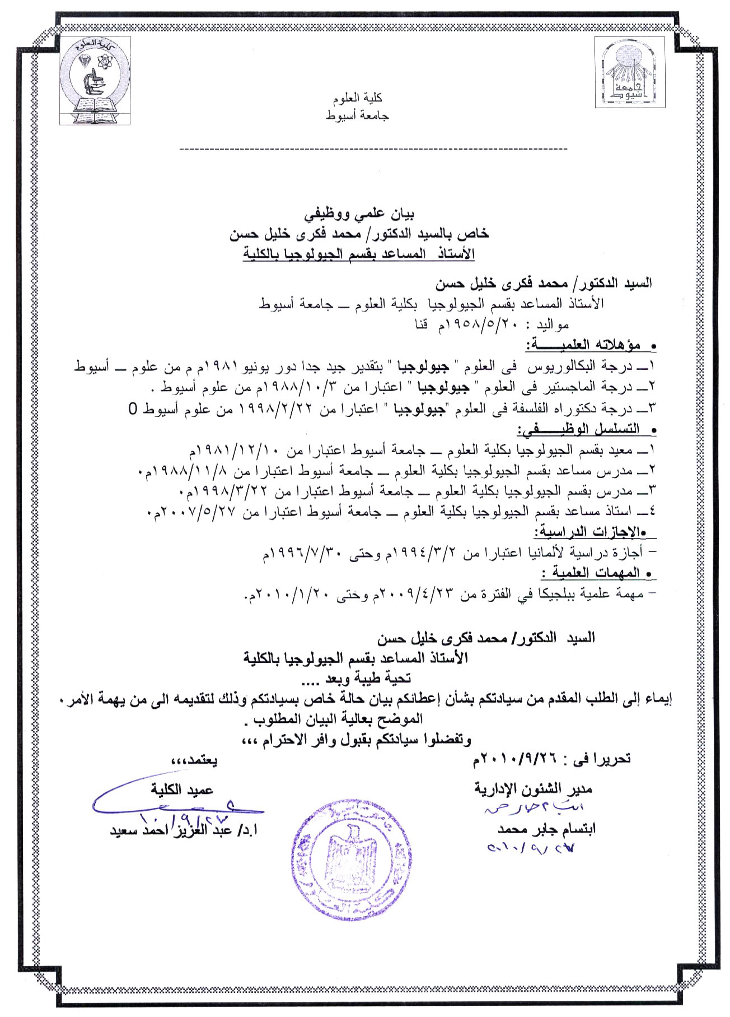
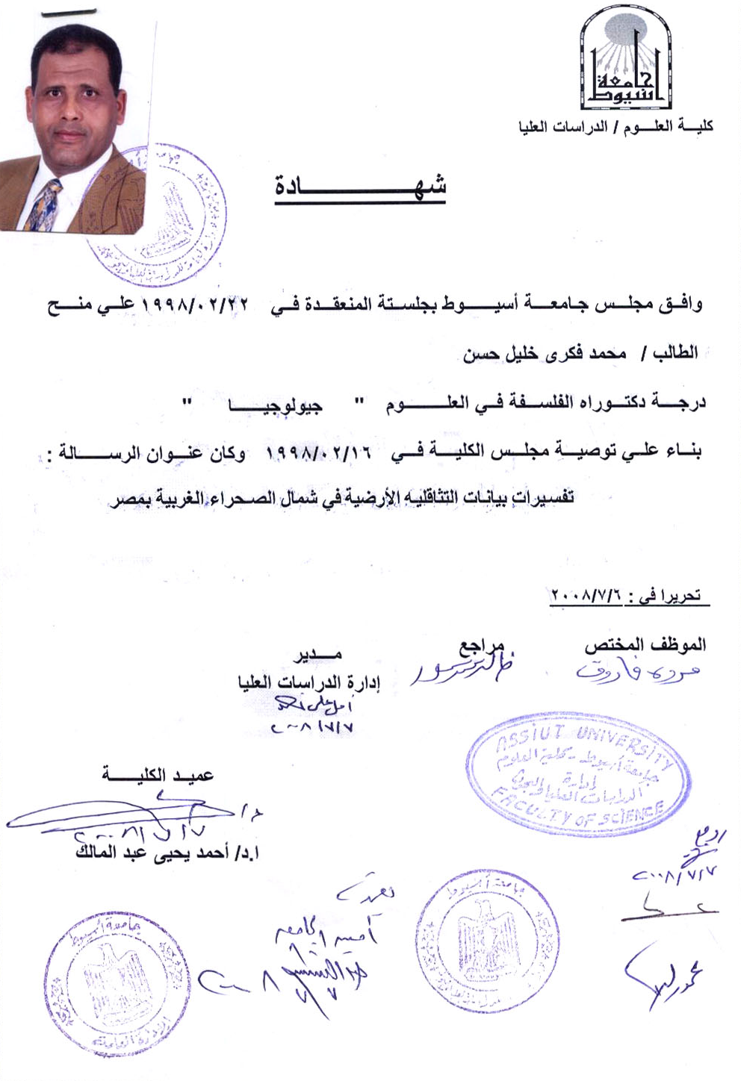
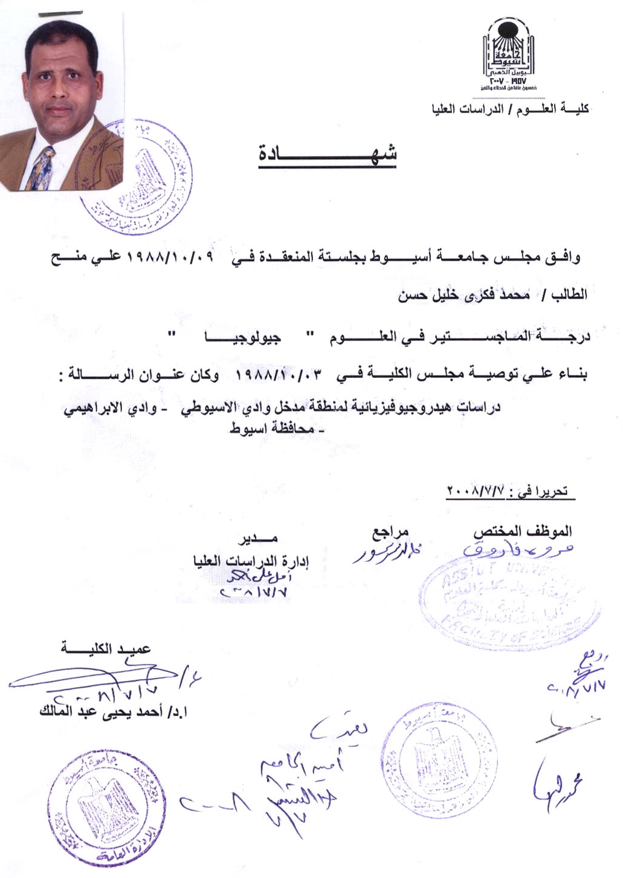
CURRICULUM VITAE
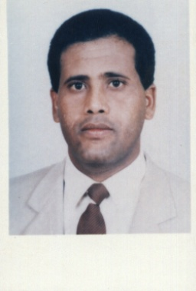
Name: Dr. Mohamed Fekry Khalil Hassan
Date of birth : May, 20, 1958
Place of brith: Luxor, Egypt
Marital Status: Married
Number of children: Three (Zeyad , Marwan & Hady)
Occupation: Associated Prof., Geology Department,
Assiut University.
Addrees : Geology Department,Faculty of Science
Assiut University. Assiut 71516 – Egypt

Telephone : +2 088/ 2315178 (home)
+2 088/ 2412290 (office)
+2 01065091765 (mobile)
+2 01007123676 (Spouse’s mobile)
Fax : +2 088/ 2342708
E-mail: Khalil20041958@yahoo.com

Academic Degrees

(June1981) B. Sc. (Very Good) in Geology. Assiut University, Assiut, Egypt.

(October 1988) M. Sc. in Geophysics. Assiut University, Assiut, Egypt

Thesis: “Hydrogeophysical investigation of the area between Wadi El-Assiuti &Wadi el- Ibrahimi, Assiut, Egypt”.

(February 1998) PhD in Geophysics. Bilateral Supervision between Free
University in Berlin and Assiut University

Dissertation: “Interpretation of Gravity Data of the North Western Desert, Egypt”.

( May 2007 ) Associated Professor of Applied Geophysics

Employment record:

1- Demonstrator: Geol. Dept., Fac. Sci., Assiut Univ., Assiut, Egypt.
(December 1981 to November 1988).

2- Assistant Lecturer: Geol. Dept., Fac. Sci., Assiut Univ., Assiut, Egypt.
(November 1988 to March 1998).

3- Lecturer of Exploration Geophysics: Geol. Dept., Fac. Sci., Assiut Univ., Assiut,
Egypt. (March , 1998 to May 2007 )

4- Associated Professor of Applied Geophysics: : Geol . Dept., Fac. Sci., Assiut
Univ., Assiut, Egypt. ( May 2007 till now )

TEACHING EXPERIENCES

1- Applied Geophysics 2- Methods of geophysical prospecting

3- Petrophysics 4- Petrolum Geology 5- Physical Geology

Previous Periods of study and Work Abroad:

- Training program in GIS for one month “July 1993” in York University, England.

- Scholarship from Egyptian Government From March 1994 to July 1996 for accomplishing the practical part of Ph.D Thesis in Free University Berlin (FUB), Germany.

- Training program in GIS and Remote sensing application in Water Resources Management,

Cartography and Geological Mapping held in Vrije university Brussel ,
Belgium on August 1- 28 , 2008.

- Postdoctor Scholarship from Erasmus Mundus ECW (lot 2) Programme, from 23, April, 2009 to February 2010, Vrije University Berlin (VUB), Belgium.

Workshops on “GIS”:

1-Workshop on Application of Geographic Information System “GIS” held in Assiut University on April, 11-12, 2005

2- Workshop on Application of Geographic Information System “GIS” held in Assiut University on February 6 - 8, 2006

3- Workshop on Geographic Information System “GIS” Basic and Fundamentals held in Assiut University on December 23-28, 2006

4-Workshop on Remote Sensing and Geographical Information System Application in Geo- Environmental Science and Water Resources held in Assiut University on January 11-12, 2007

EXPERIENCES AND COMMUNITY SERVICES

Research member in investigation and evaluation of the ground water aquifers in Wadi El Assiuti and supervising on drilling and development of the ground water wells in the area ( 1992).

Research member in the investigation and evaluation of the ground water aquifer of Wadi Qena and supervising on drilling and development of the ground water wells in the area (1995).

Research member in investigation and evaluation of the ground water aquifer of Wadi El-Nukra, Kom Umbo, Aswan and supervising on drilling and development of the ground water wells in the area (1996).

Research member in studying suitability of the proposed desert site of the new Assiut city for constructions from the geophysical point of view using geoelectric, seismic and aeromagnetic methods ( 1999).

Research member in the project of investigation and evaluation of the ground water aquifer of the farm of Egyptian Company of Sugar and Distillation and supervising on drilling and development of the ground water wells in the area

List of Publications:

Khalil M.F. (1988): Hydrogeophysical Investigation of the area between Wadi El-Assiuti and Wadi El-Ibrahimi, Assiut, Egypt, M.Sc.Thesis, Geology Dept., Assiut University,150 p.

Omran A.A., Riad S. and Khalil M.F. (1994): Groundwater Exploration in the area between Wadi El-Assiuti and Wadi El-Ibrahimi, Assiut, Egypt. Bull.Fac. Sci., Assiut
Univ.,Vol.23, No. 1-F pp. 53-79.

Khalil M.F.(1998): Interpretation of Gravity Data of the North Western Desert, Egypt, Ph.D. Thesis, Geology Dept., Assiut Univ., 178 p.

M. M. Senosy and Khalil M.F. (2002): Impressments of drap aeromagnetic data to release some ideas about the tectonic origin of the Ophiolite sequence in the area around Gabel Uref Um Araka and Gabel Abu Dahr, Southeastern Desert, Egypt. Bull.Fac. Sci., Assiut Univ. Vol. 31, No. 2-F, pp. 165-188

Khalil, M.F., M.M. Senosy, and A.M. Ebraheem (2003): Application of 2D imaging earth resistivity method for determining the hydrogeological conditions for the coastal area between Marsa Matruh and Ras El Hekma, Mediterranean Coast, Egypt. N. Jahr. Für Geologie und Paläontologie, Stuttgart 229(2), pp. 255-279

Senosy,M.M. Dahab,K.M. Khalil, M.F, and Ebraheem, A.M. (2004): The environ- ment impact of groundwater level rising using the 2D imaging earth resistivity and hydrogeological methods in Markz Badr District, West of Nile Delta, Egypt. Proc. The 3rd International Symposium on Geophysics, Tanta university, pp. 520- 540

khalil, M.F. (2005): Geoelectrical Studies for groundwater exploration on Wadi Sannur and Wadi El- Gayed, East Nile Valley, Egypt. The fourth International Conference on the Geology of Africa, Assiut University, vol. (1), pp.729-738.

Bakheit, A.A, Khalil, M. M., and Ibrahim, H.A. (2006): Geoelectrical resistivity measurements for groundwater exploration in the area Northwest of Assiut, western part of Nile Valley, Egypt. Bull. Fac. Sci., Assiut University, 35 (2), pp. 85 - 103

Bakheit, A.A.; Khalil, M.F.; El-Hadad, A.E. and Hammad, A.M.(2006): Surface and subsurface tectonic pattern as interpreted from aeromagnetic data at El-Dakhla region, Western Desert, Egypt. Bull. Fac. Sci., Assiut University, 35 (2), pp. 57-83.

Senosy, M. M., Khalil, M. F. (2006): Geoelectrical studies for groundwater exploration in the areas around Gebel Abraq, southern Eastern Desert, Egypt. Bull. Fac. Sci., Assiut University, 35 (2), pp. 39 - 56

H.A.Ibrahim, M.F.khalil and M.O.Ebraheem (2008): Geoelectric Sounding and Hydrochemical Investigations for Groundwater Potentiality in the Area West of the River Nile, Assiut, Egypt. The fourth International Conference for Development and the Environment. King Saud University, Riyadh – Saudia Arabia March 18 – 20 (abstract).
